**BAYES’ THEOREM**

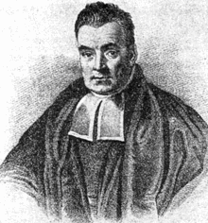

**Blue/Orange/Yellow:** Conditions given to support the prior knowledge and increase the probability of a given event.

**Their intersection** represents the surety/probability of an event to occur, the lesser the intersection is, more accurate will be the guess (probability will be high).

**BAYES’ THEOREM USING VENN DIAGRAMS**

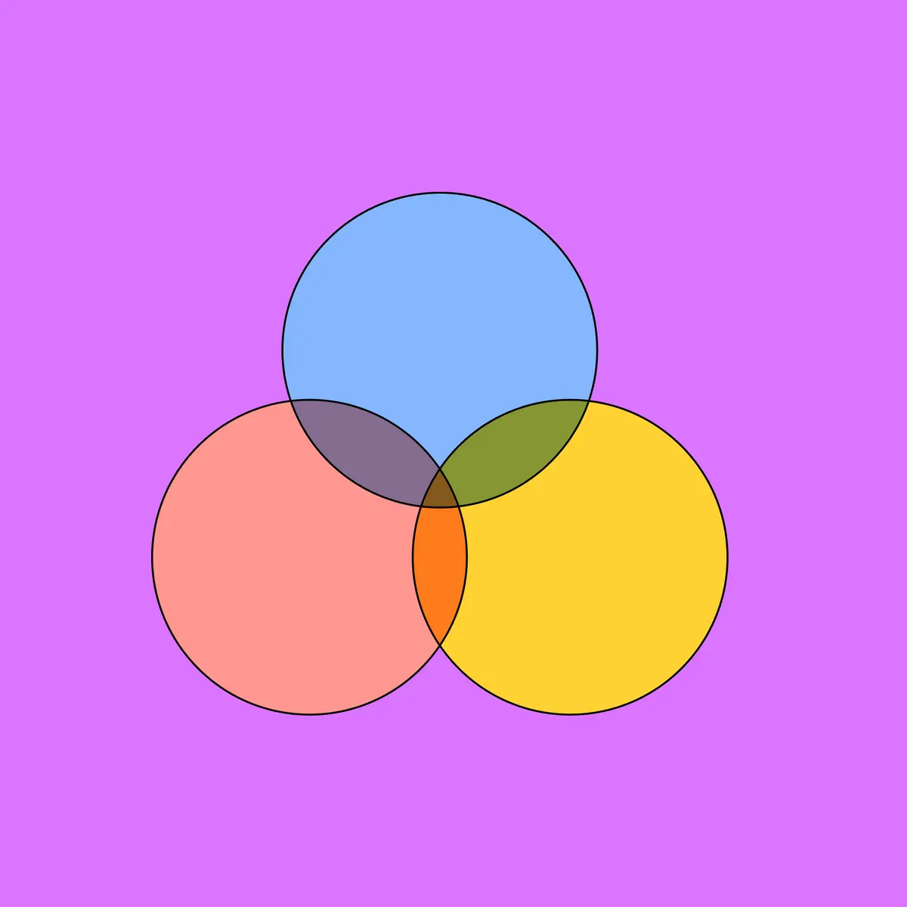

**Extended Form:**

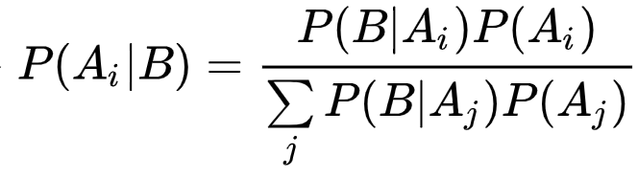

In the special case where A is a binary variable:

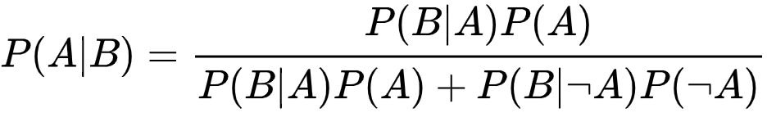

**For Continuous Random Variables:**

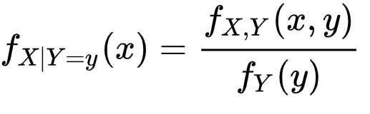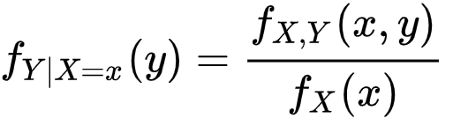

Therefore,

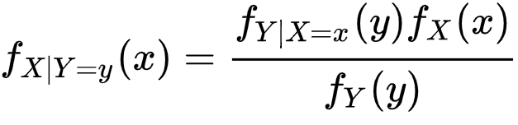

**Conditioned Version:**

A conditioned version of Bayes’ theorem results from the addition of a third event C on which all probabilities are conditioned:

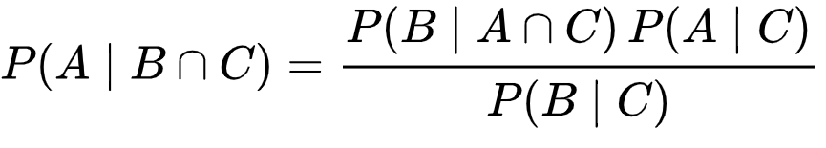

**For Events:**

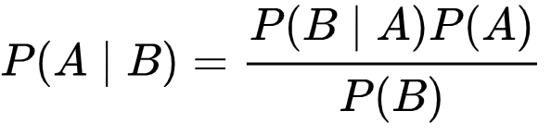

* P(A) = The probability of A occurring
* P(B) = The probability of B occurring
* P(A | B) = The probability of A given B
* P(B | A) = The probability of B given A

Bayes' Theorem, named after 18th-century British mathematician Thomas Bayes, is a mathematical formula for determining [**conditional probability**](https://www.investopedia.com/terms/c/conditional_probability.asp). Conditional probability is the likelihood of an outcome occurring, based on a previous outcome having occurred in similar circumstances. Bayes' theorem provides a way to **revise existing predictions or theories** (update probabilities) given **new or additional evidence**.